Curriculum Vitae
Personal Data
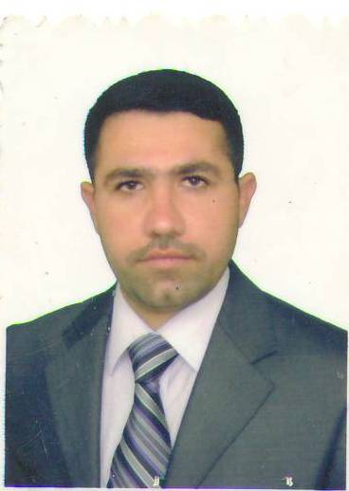
Full Name: Mohammed H AL-khafaji
Date of birth: 16/7/1980
Place of Birth: Bagdad- Iraq
Address: Bagdad, Iraq
Phone: 00447741392449
E-mail: mo80ali85@yahoo.com
Nationality: Iraqi
Gender: Male
Marital Status: Married

Main research interests
- Power system analysis
- Power system control strategies,
- Smart grid power system

Work experience
Dates: December 2006 onward
Occupation: Assistant Lecturer
Position held: Electrical Engineering Department in University of Technology

Education and training
Dates: 2004-2006
Title of qualification awarded: M.Sc.
Principal subjects: Maximum power transfer limited by voltage stability in electrical power system
Overall average: 81.235
Name organisation providing education: University of Technology
Dates: 1999-2004
Title of qualification awarded: B.Sc.
Principal subjects: Electrical Engineering
Overall average: 70.498 with rank (1) out (54)
Name organisation providing education: University of Technology

Main publication:

"Particle swarm optimization for total operating cost minimize in electrical power system", Eng. & Tech. Journal, Vol.29 No.12, 2011

Main academic activities:
I worked in various types of team Laboratory (power electronics team, machines team, high voltage team), deliver lectures in Electromagnetic tutorial subject, and supervisor for students at B.Sc. studies, member of subjects’ discussion committee for the B.Sc. studies for the last grade

Personal skills and competences:
Mother tongue: Arabic
Other language: English

Technical skills and competences:,

- I worked in a Company for building as institution of electrical and for a company as installation of generators.
- MATLAB software package programming and simulation skills acquired during my M.Sc. Program and post-M.Sc. academic career.
- OrCad + PSIM software programs for simulation acquired during my academic career.

Other skills and competences:
I worked in Post Graduate Unit (2009-2012), student follow-up committee (2007-2009), and other committee in my department.

